Ideation Phase
Define the Problem Statements

Date | 26 june 2026
Team ID | Solo
Project Name | ShopEZ ecommerce application
Maximum Marks | 2 Marks

Customer Problem Statement Template:
Create a problem statement to understand your customer's point of view. The Customer Problem Statement template helps you focus on what matters to create experiences people will love.
A well-articulated customer problem statement allows you and your team to find the ideal solution for the challenges your customers face. Throughout the process, you’ll also be able to empathize with your customers, which helps you better understand how they perceive your product or service.
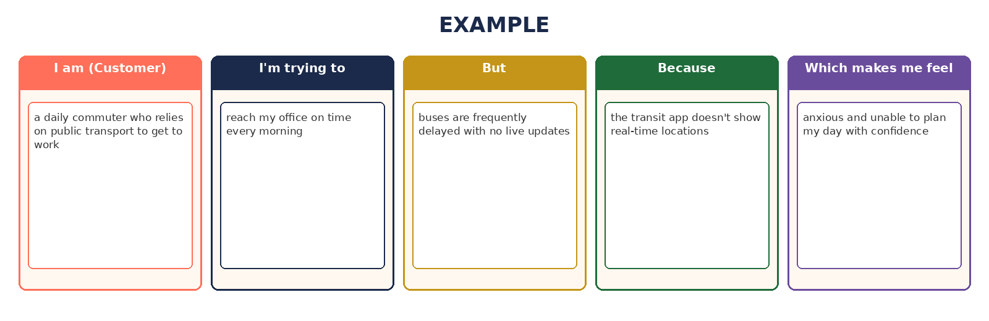
Example
Problem Statement (PS) | I am (Customer) | I’m trying to | But | Because | Which makes me feel
PS-1 | an everyday online shopper who wants to support local and small-to-medium retailers | find good quality products at fair prices from sellers I can trust, with a smooth checkout | most e-commerce apps feel generic, cluttered, and make it hard to know if a small seller is reliable | existing platforms are built around large, mass-market catalogs and templated storefronts, not a curated, boutique-style experience | hesitant to shop from smaller sellers, and frustrated by clunky search, filtering, and multi-step checkout flows
PS-2 | a small-to-medium retail merchant trying to grow my business online | sell my products digitally and manage orders, inventory, and revenue without hiring a technical team | affordable e-commerce solutions rarely give me a proper dashboard to track my business | most platforms either lock small sellers into expensive plans or offer only bare-bones listing tools with no analytics | overwhelmed and left behind, unsure whether going online is worth the effort

